**Module 3.HTML**

**1) Are the HTML tags and elements the same thing?**

**=>**No, HTML tags are used to hold the HTML element. HTML element

holds the content.

**2) What are tags and attributes in HTML?**

**=>** HTML tags are used to hold the HTML element. HTML element holds

the content. HTML attributes are used to describe the characteristic of an

HTML element in detail.There are so many tags in HTML.

Ex,<html>,<head>,<title>,<body>,<h1>,<p>,<a>,<img>,<div>,

<span>,etc.

=>There are so many attributes in HTML.Ex,href,src,height, width,alt,

style,lang,title,etc.

**3) What are void elements in HTML? With Example.**

**=>**A void element is an element whose content model never allows it to

have contents under any circumstances.Ex,<br>, <hr>,<img>,<input>,

<link>,<area>,<embed>,<col>,<source>,etc.

**4) What are HTML Entities? With Example**.

**=>** Some characters are reserved in HTML and they have special meaning

whenused in HTML document. For example, you use the greater than

and less than signs or angle brackets cannot within your HTML text

because the browser will treat them differently.

**5) What are different types of lists in HTML? With Example.**

**=>** There are three list types:

unordered list — used to group a set of related items in no particular

order.

ordered list — used to group a set of related items in a specific order.

description list — used to display name/value pairs such as terms and

definitions.

**6) What is the ‘class’ attribute in HTML? With Example.**

**=>** The class attribute specifies one or more classnames for an element.The

class attribute is mostly used to point to a class in a style sheet. Ex,All

HTML elements Attribute class.

**7) What is the difference between the ‘id’ attribute and the ‘class’**

**attribute of HTML elements? With Example.**

**=>**A Class name can be used by multiple HTML elements, while an ID

name must only be used by one HTML element within the page.

**8) What are the various formatting tags in HTML?**

**=>** Formatting elements were designed to display special types of text:

<b> - Bold text.

<strong> - Important text.

<i> - Italic text.

<em> - Emphasized text.

<mark> - Marked text.

<small> - Smaller text.

<del> - Deleted text.

<ins> - Inserted text.

**9) How is Cell Padding different from Cell Spacing? With Example.**

=>Cellpadding basically defines the space present between a table cell's

border and the content present in it. Cellspacing basically defines the

space present between individual adjacent cells. One can create it using

the tag of HTML <table>, but it sets the type attribute to cellpadding.

Ex.

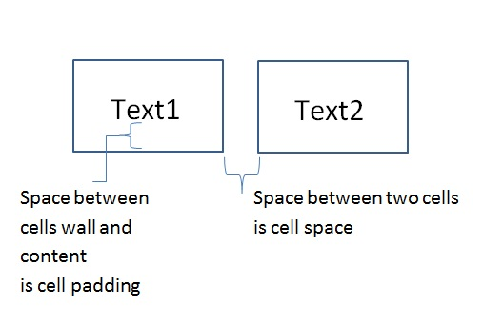

**10) How can we club two or more rows or columns into a single row or**

**column in an HTML table? With Example.**

**=>** We use the colspan and rowspan attribute, to merge cells in HTML.The

rowspan attribute is for the number of rows a cell should merge, whereas

the colspan attribute is for the number of columns a cell should merge.

The attribute should be placed inside the <td> tag.

Ex.

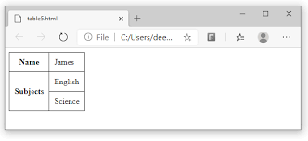

**11) What is the difference between a block-level element and an inline**

**element?**

**=>** Difference Between Inline and Block Elements in HTML Block

elements always start from a new line. Inline elements never start from a

new line. Block elements cover space from left to right as far as it can

go. Inline elements only cover the space as bounded by the tags in the

HTML element.

**12) How to create a Hyperlink in HTML? With Example.**

=> A hyperlink, also called a link or web link, contains an address for a

destination and acts as a reference to data. A user can easily follow, jump

to, and be directed to the destination by either clicking, tapping on, or

hovering over the link.

Ex. <a href="url">link text</a>

**13) What is the use of an iframe tag? With Example.**

**=>** The iframe in HTML stands for Inline Frame. The “ iframe ” tag defines a

rectangular region within the document in which the browser can display a separate document, including scrollbars and borders. An inline frame is used to embed another document within the current HTML document.

Ex.

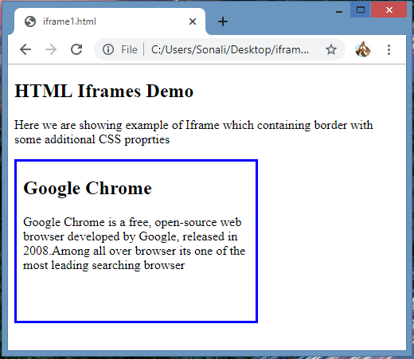

**14) What is the use of a span tag? Explain with example?**

**=>** The span tag is a paired tag means it has both open(<) and closing (>)

tags, and it is mandatory to close the tag. The span tag is used for the

grouping of inline elements & this tag does not make any visual change

by itself. span is very similar to the div tag, but div is a block-level tag

and span is an inline tag.

Ex.

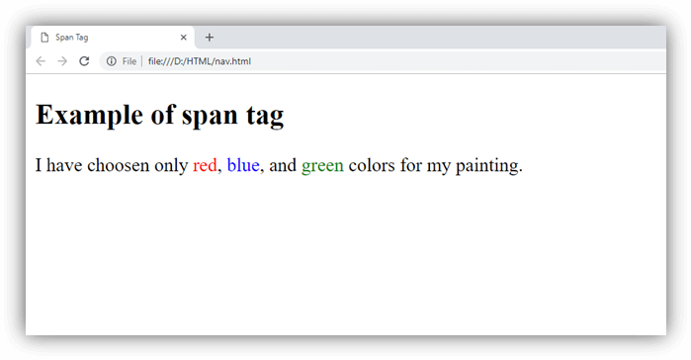

**15) How to insert a picture into a background image of a web page?**

**With Example.**

**=>** The easiest method to add a background image to a webpage is using the

background attribute in the <body> tag of HTML. This will add a

background image to the whole page. Syntax: Where image_name is the

name of the image and image_extension is the extension of the image

based on the format.

Ex.  <Body background="filename. extension">

**16) How are active links different from normal links?**

=>By default, a link will appear like this (in all browsers): An unvisited link

is underlined and blue. A visited link is underlined and purple. An

active link is underlined and red.

**17) What are the different tags to separate sections of text?**

**=>** We separate a section of texts in HTML using the below tags:

* <br> tag – It is used to separate the line of text. It breaks the

current line and shifts the flow of the text to a new line.

* <p> tag–This tag is used to write a paragraph of text.
* <blockquote> tag–This tag is used to define large quoted sections.

**18) What is SVG?**

**=>**SVG is a language for describing 2D graphics in XML. Canvas draws

2D graphics, on the fly (with a JavaScript). SVG is XML based, which

means that every element is available within the SVG DOM. You can

attach JavaScript event handlers for an element.

**19) What is difference between HTML and XHTML?**

**=>**HTML stands for Hypertext Markup Language, whereas XHTML

stands for Extensible Hypertext Markup Language. XHTML is basically

an extension of HTML, which is stricter than HTML. Both languages

are used to create web and Android applications. HTML is SGML

based, whereas XHTML is an XML-based language.

**20) What are logical and physical tags in HTML?**

**=>**In HTML the formatting tags are divided into two categories: Physical

tag: These tags are used to provide the visual appearance to the

text. Logical tag: These tags are used to add some logical or semantic

value to the text.